Press release
17 February 2021

Safe across disciplines
Automatic test routines and quality certificates in engineering

With the latest version of its cooperation platform Engineering Base (EB), Aucotec AG will be introducing a new security package for engineering experts in plant engineering in time for the virtual Hannover Messe (Hanover Trade Fair) 2021. From quality assurance tools via automated intrinsic safety calculation (Ex-i) to the justiciable e-signing of the digital twin, Aucotec has expanded the issue of security in the data-driven platform:

Signed and sealed quality
Engineering experts regularly check whether everything is correct during the design process. Supplied documentation is also checked. The visual inspection, which is still common even during final comprehensive tests, involves an enormous amount of time – without any guarantee of complete accuracy. EB, however, cannot "overlook" anything. Thanks to object orientation and a universal data model, all disciplines involved are combined in the system. It knows all the logic and links. The new quality management not only checks automatically for inconsistencies or non-compliance with requirements, it also automatically creates a list of all discrepancies per check and describes them. You can navigate to the conspicuous object directly from the list and correct the error. If everything is correct, the delivered project contains a certificate in the form of a test sheet with a green seal, which proves its correctness and is visible at first glance. Instead of weeks of work, the check takes a few hours at most. While initially developed for energy technology plants, this new QA framework can now also be used in other industries.

Safe Ex-i calculation by clicking
Where explosive atmospheres can arise, electrical sensors and actuators and their circuits must not cause ignitable sparks or excessively high surface temperatures. The intrinsic safety (Ex-i) of all associated equipment, lines and circuits must be reliably proven for the operating license, which is a major responsibility!

In EB, Ex-i data can be directly catalogued and maintained in order to design intrinsically safe circuits. In addition, intrinsic safety can be calculated and documented directly in the system by an Assistant, also as a typical. Up to now, this has usually happened in an extra tool in which external catalogue data has been entered. The Ex-i-Assistant, however, calculates all relevant circuits of a plant in accordance with IEC 60079-14 at the touch of a button, in only one process if required. EB keeps all information together, from the device and prototype test certificates via loop diagrams up to the calculation documentation. This saves laborious searching and error-prone data transfers.

Electronically signed and certified - FDA compliant
Absolutely flawless and legally-compliant documentation is required for plants in various industries. EB supports this requirement with multiple capabilities that meet even the strict regulations of the U.S. Food and Drug Administration (FDA), which has set standards worldwide. (Title 21 eCFR Part 11) The required e-recording covers EB with cross-disciplinary tracking of all changes to each asset, including its complete change history. Due to its multi-layer architecture, this information can also be accessed in a securely encrypted manner via a web service. In addition, EB now also enables legally-compliant e-signatures on plant documents. This includes a link to the certificate of signature authorization, time stamps, identification codes and password-protected accesses, among other things.

Aucotec at virtual Hanover Fair ‘21: Access data as of beginning of March via www.aucotec.com

Links to the images*:

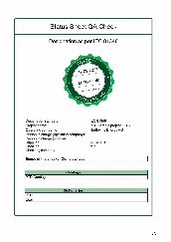
QA tools for automated test routines create sealed quality in Aucotec's Engineering Base (Image: AUCOTEC AG)
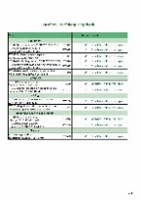
2nd page of seal document with check details (Image: AUCOTEC AG)
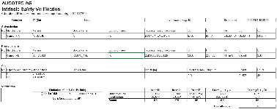
Calculation of intrinsic safety including verification with EB’s Ex i assistant (Image: AUCOTEC AG)

Intrinsic safety verification within EB’s Ex i assistant (Image: AUCOTEC AG)

*These images are protected by copyright. They may be used for editorial purposes in connection with Aucotec.

If printed, we would appreciate receiving a copy. Thank you very much!
AUCOTEC AG, Hannoversche Straße 105, 30916 Isernhagen, www.aucotec.com
Press and Public Relations, Johanna Kiesel (jki@aucotec.com, +49 (0)511 6103186)

___________________________________________________________________________
Aucotec AG has over 35 years of experience in developing engineering software for the entire lifecycle of machines, plants and mobile systems. The solutions range from flow diagrams via I&C and electrical engineering for large-scale plants to modular harness design in the automotive industry. Aucotec software is in use all over the world. In addition to its headquarters in Hanover, Aucotec operates six further sites in Germany as well as subsidiaries in China, South Korea, France, the United Kingdom, Italy, Austria, Poland, Sweden, Norway and the US. A global network of partners ensures local support throughout the world.

